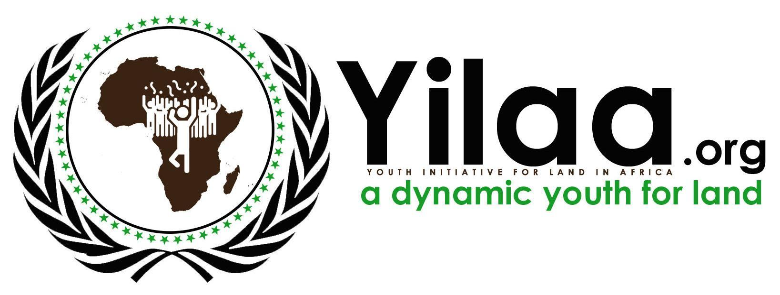
THE THIRD INTERNATIONAL YOUTH LAND GOVERNANCE CONFERENCE (CIGOFA3) │ 2022

Date: 12 to 15 October 2022
Tentative Venue: Dakar (Senegal)

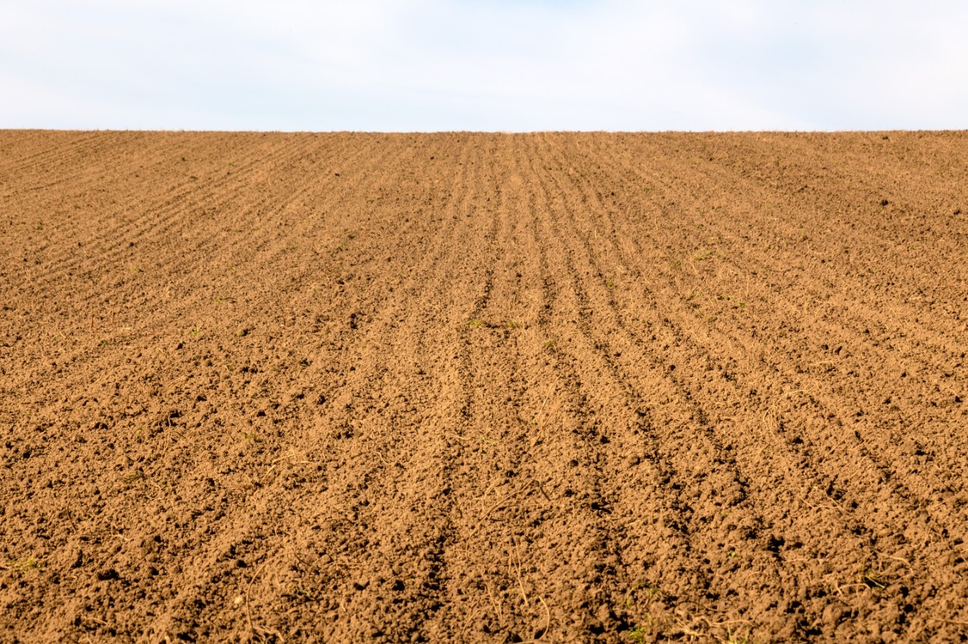

Youth Access to Land for Peace and Security in Africa.

1 CONTEXT 2
2 THE THIRD INTERNATIONAL YOUTH LAND GOVERNANCE CONFERENCE (CIGOFA3) - 2022 4
2.1 OBJECTIVES AND EXPECTED OUTCOMES 5
2.1.1 OBJECTIVES: 5
2.1.2 EXPECTED OUTCOMES 5
2.2 PARTICIPANTS AND PARTNERS 6
2.2.1 PARTICIPANTS 6
2.2.2 ORGANISERS 6
2.3 TIME FRAME 6
2.4 FUNDING 6

CONTEXT
Years after the beginning of the security crisis in the Sahel, Africa is the scene of coups de force perpetrated by officers anxious to rebuild their states. In the face of these democratic setbacks, what role can African youth play?
The Peace and Security Council (PSC) of the African Union (AU) at its 1067th meeting held on March 3, 2022 on the theme : Youth, Peace and Security in Africa, underlined in Article 7 of its Protocol the important role that youth play at national, regional and continental levels in preventing violence, promoting peace, security, stability and socio-economic development and laying the foundations for peaceful societies, as part of the implementation of the AU Master Roadmap on Practical Measures to Silence Arms in Africa by 2030, and Aspiration 4 of Agenda 2063, the Continental Framework on Youth, Peace and Security (CFYPS) and its 10-year implementation plan, as well as UN Security Council Resolutions 2250 (2015), 2419 (2018) and 2535 (2020).
Africa remains the youngest continent in the world with a median age of 19.7 years. By 2050, one in three young people will live in sub-Saharan Africa. Yet 80 to 90 percent of African workers are still in the informal economy. Each year, 10 to 12 million young Africans enter the labor market, but only three million formal jobs are created each year.
These data show how much youth employment or job creation is a solution to socio-economic peace in our states, to illegal immigration, to extremism. Therefore, young people must be oriented towards sectors that constitute a real opportunity for development, peace and security in Africa and then for their empowerment. These include agriculture, environmental protection, climate justice, etc.
To this end, the access of young people to land is an obligatory passage that must make states think. Therefore, states and institutions must: work to restore degraded land, install young people in agricultural cooperatives, create new classes of agri-preneurs with an innovative system of agribusiness, accompany the training and capacity building of young people on leadership and effective use of land, accompany young people to land mapping, accompany to limit illegal immigration, accompany young people in research work...
The land is 80% a resource for job creation for youth and women and for food security capable of alleviating the famine that hangs over the continent and contribute to the cessation of wars unbalancing the peace of Africa.
YILAA as a Pan African Youth Led Organisation has established the CIGOFA as the ultimate opportunity for young Africans regardless of their location in the word to exchange knowledge on land governance related issues in Africa and take actions to solve them. Moreover, CIGOFA is solution-oriented as it allows participants to propose solutions and initiatives to radically improve land governance for youth that is sensitive to security and peace in Africa. It is therefore about food security, border security, social security, economic security and socio-economic peace.... It is imperative to stress that CIGOFA intends to progressively place youth at the heart of land governance in Africa.
The previous edition of the CIGOFA that was hosted in Cotonou in Benin, aligned with the Agenda 2063 and Africa Union Land Governance strategies has stated that the data collection, research, food security and peace involvement in Youth Land Access process as the important recommendations.
So, CIGOFA3 will help to deepen capacity for land policy in Africa through improved access to knowledge and information on land policy making and implementation. The theme for CIGOFA3 is: “Youth Access to Land for Peace and Security in Africa” which aligns with the African Union theme of the year: “Strengthening resilience in nutrition and food security on the African continent”.
To achieve the vision of the CIGOFA, during this third edition of the conference, we need to bring an inclusive and participatory approach in the following areas:
- Land data collection , mapping and localization
- Land and SDGs and how youths can contribute in achieving the SDGs, what next after SDGs?
- Economic, Political, and Social Drivers, infrastructures, Cities, and Local Action
- Climate Financing
- Job creation related Youth Land Access
- Women Land rights and property rights
- Youth, training and capacity building
- Food security
- Peace and security
- Public mobilization

The youth need to reconnect to the source in order to have real good practices to facilitate peace and security in Africa countries. And, this depends on youth access to land.
So, we must better reflect on this target and analyze their involvement and then their correlation with the youth access to the land work in Africa for a better peace and security of our Continent.

THE THIRD INTERNATIONAL YOUTH LAND GOVERNANCE CONFERENCE (CIGOFA3) - 2022
The Third Youth Land Governance Conference is an international event organised by YILAA and its partners themed: “Reflect on Youth Access to Land for Peace and Security in Africa”. And develop strategies and recommendations to mitigate these issues.”
The theme of our conference enables African youth to master good practices in accessing land for agricultural production, peace and security. In the same way, to know the strategies of sustainable management of the lands guaranteeing a healthy nutrition and biology of the population thus contributing to the achievement of the SDGs and Voluntary Guidelines on the Responsible Governance of Tenure (VGGTs). This is in line with the theme of the Year 2022 of the African Union.
This event, is taking place at a time when every sector is shaken by the Coronavirus (COVID-19) pandemic. Moreover, it offers a golden opportunity to reflect and highlight the relevant role of youth for better security and peace in the future. It also offers a platform to push the frontiers of thought to deliberate on the issue of youth and push their land agenda to top high-pressure discussions while ensuring that stakeholders and governments feel the urgency to act.
The Third International Youth Land Governance conference will focus on the following objectives, key to the delivery of Agenda 2063 of the African Union:

OBJECTIVES AND EXPECTED OUTCOMES

OBJECTIVES:

- Enable States and identify youth as agents of change in matters of land rights, security and peace;
- Support the government, INGOs, NGOs, CSOs and other actors to collect and avail land data in relationship with security and peace;
- Empower youth on the importance of bottom-up approach as a way of enabling inclusion in the land sector
- Provide a platform to share youth involvement related good practises to improve land governance, security and peace;
- Educate youth on the value of land data in their quest to own, access, and use land.
- Explore the innovative approach that youths and young women can use to advocate for security and peace through their access to land.

EXPECTED OUTCOMES
- Creation of a multi-sector, multi-stakeholder platform for the coordination of youth land , security and peace interventions that would promote economic growth.
- Strengthened monitoring, evaluation and accountability framework using relevant frameworks that promotes land rights, security and peace;
- Research related training opportunities are mobilised to increase the number of African young professionals in land governance, security and peace.

PARTICIPANTS AND PARTNERS

PARTICIPANTS
YILAA members, partners, academia and other interested groups from the public are welcome to join. If you are interested in participating, or partners with us on this continental event please write to: ahouedji@yilaa.org or yilaacomms@gmail.com

ORGANISERS
The event is organised by YILAA and its partners.

TIME FRAME
12 to 15 October 2022

FUNDING
The event will be supported by the partners working on land and climate justice in the Global. To support CIGOFA kindly click here to illustrate the kind of support that you will offer.

http://www.peaceau.org/fr/article/communique-de-la-1067e-reunion-du-cps-tenue-le-3-mars-2022-sur-le-theme-jeunesse-paix-et-securite-en-afrique

